CV and Major Scientific Achievements – Mauricio Federico Erben

- Personal Information
Born in Chajarí, Entre Ríos, República Argentina, 1-11-1975
Argentinean citizen ID: 24.732.696
Adress: Calle 121 Nº 2383 (e/80 y 81), La Plata (CP 1900), Buenos Aires, Argentina

Business Address:
Inorganic Chemistry Center (CEQUINOR)
Department of Chemistry, Exact Sciences Faculty, Nat’l University of La Plata
CC 962 La Plata (CP 1900) La Plata, Buenos Aires, República Argentina
Tel./Fax: ++54-(0)221-425-9485
E-mail: erben@quimica.unlp.edu.ar http://cequinor.quimica.unlp.edu.ar/dr__mauricio_erben
Google Scholar ID: https://scholar.google.com/citations?user=6vVh7dkAAAAJ&hl=es

- Education
  - Licenciado in Chemistry. Faculty of Exact Sciences. Nat’l University of La Plata (2000)
  - Chemistry and Physics Professor, Faculty of Humanities and Education Sciences,Nat’l University of La Plata (2005)
  - Doctor de la Facultad de Ciencias Exactas, PhD. Nat’l University La Plata (2005)
  - Post-Doctoral Research Training, University of Bielefeld (Germany). (2012)

- Employment history including current positions
- 2001 – Mar 2005. Graduate Fellow of CONICET
- 2007-2009- Assistant Research of CONICET
- 2009-2011- Adjunct Research of CONICET
- 2011-current: Independent Research of CONICET, Argentina.

1996 –2005. Teaching Assistant, Department of Chemistry, UNLP
2007-current- Adjunct Regular Professor. Inorganic Chemistry, Department of Chemistry, Faculty of Exact Sciences, Nat’l University of La Plata.

4. Institutional responsibilities
- Professor member of the Academic Council of the Faculty of Exact Sciences, Nat’l University of La Plata2014-2018.
- Designated as Academic consultant (Chemistry peer commission) of CONICET (National Research Council, Argentina). 2015-2017.

5. Approved research projects
- PICT 2006-1308 (type B – Youngh researchers). Agencia Nacional de Promoción Científica y Tecnológica (Argentina). Proyect title: Síntesis, structure and bond properties of molecuar inorganic cmopounds. $ 25.000, 2008-2010.

- PICT-2013-2130 (type I). Agencia Nacional de Promoción Científica y Tecnológica (Argentina). Proyect title: Volatiles emerging contamiants,: electronic structure and dissociation channels determined by synchrotron radiatio. $ 182.691. 2014-2017.

- Redes VIII and IX. “Network program”. Ministry of Education. Proyect title: “Network of universities for the research and development of sustainable alternatives applied to ambient problems (Part II)”. Universidad Nacional de La Plata, Universidad Nacional Arturo Jauretche, Universidad de La Habana, Cuba, Universidad Nacional Mayor de San Marcos, Perú, Universidad Nacional de Asunción, Paraguay. $ 84.000. 2016.

6- Supervision of junior researchers
PhD / MSc students supervised
Period of Study | Candidate | Degree | Present or subsequent position
2007-2008 | Lucas Rodríguez Pirani | MSc | Post Doc fellow Argentina
2007-2008 | Emiliano Cortés | MSc | Post Doc Fellow UK
2010-2011 | Antonela Canneva | MSc | PhD student
2013-2014 | Vanina Cayón | MSc | PhD student
2008-2013 | Lucas Rodríguez Pirani | PhD | Post Doc student
2010-2014 | Angélica Moreno | PhD | Post Doc student
2011- | Antonela Canneva | PhD | Post Doc student
2012- | Zuly Yuliana Delgado | PhD
2014- | Vanina Cayón | PhD
2016- | Diana L. Nossa | PhD

Postdoctoral research fellows supervised
Period of Employment | Fellow | Present position
2009-2011 | Dra. Sonia Torrico Vallejos | Researcher at Cochabamba, Bolivia
2010-2011 | Dra. Nahir Dugarte | Laboratory of Water Quality, Ecuador
2013-continue | Lucas Rodríguez Pirani | Post Doc student
2013-2015 | Sergio Laurella | Post Doc Student

7-Theaching activities
- 22 years experience teaching chemistry lectures at the Department of Chemistry, Faculty of Exact Sciences, Nat’l University of La Plata. Currently as Prof. of Inorganic Chemistry.
- Post-graduate courses in topics related with molecular structure of covalent species.

8- Memberships in panels and individual scientific reviewing activities
Reviewer of ca. 100 scientific articles submitted to 40 different journals of the chemistry discipline, including leading ACS, RCS, Elsevier and Wiley editorials.

9- Active membershipts in scienfic societies, fellowships in renowned academies
    - Fellow of the Argentinean Association of Researches in Physical Chemistry.
    - Fellow of the Argentinean Association of Chemistry Teachers
    - Affiliated Member of the TWAS, selected by the TWAS-ROLAC Office (Regional office for Latin-American and Caribbean) 2012-2017.

10- Organization of conferences
Member of the Organizing Comitee of the “Jornadas de Química Inorgánica Prof. Emér. Dr. Pedro J. Aymonino”. Faculty of Exact Sciences, UNLP. 2010, 2012, 1014.

11- Prizes and Award
- Joaquín V. González Award 2000. Prize awarded each year by the government of La Plata city to the best student of the Nat’l University of La Plata.
- “Award to the scientific, technique and artistic labor of the University of La Plata” (Young Research Category) 1st Edition 2010, because of his “activity as a research and teacher in the Chemistry Department and his outstanding scientific production as a member of the Center of Inorganic Chemistry (CEQUINOR)”.
- Award "José Galvele" in Chemical Sciences (Young researchers), National Academy of Exacts, Physics and Natural Sciences (ANCEFN, Argentina), 2012.
- Award "Innovar" 2017 in Applied Reseach. Ministery of Science, Technology and Innovation (MinCyT), Argentina.

Major scientific achievements - Mauricio Federico Erben

From 2002, 105 contributions were co-authored, including a review article. According to Scopus/Google Scholar these articles were cited 1133/1227 times (h= 20/21). Selected publications in the last five years are showed, most relevant articles are boldfaced and the year of publication is clearly visible. The role as corresponding author is marked “*”

“Electronic Properties and Dissociative Photoionization of Thiocyanates, Part II. Valence and Shallow-core (Sulfur and Chlorine 2p) Regions of Chloromethyl Thiocyanate, CH₂ClSCN” L. S. Rodríguez Pirani, M. Geronés, C. O. Della Védova, R. M. Romano, A. Fantoni, R. Cavasso-Filho, C. Ma, M. Ge, M. F. Erben*. The Journal of Physical Chemistry A, 2012, 116, 231–241. DOI: 10.1021/jp208232t

“Dissociative Photoionization of Methyl Thiochloroformate, ClC(O)SCH₃, following Sulfur 2p, Chloride 2p, Carbon 1s and Oxygen 1s Excitations” M. Geronés, M. F. Erben, R. M. Romano, R. L. Cavasso Filho, C. O. Della Védova, The Journal of Physical Chemistry A, 2012, 116 (28), 7498–7507. DOI: 10.1021/jp302164t

“Twisted imide bond in non-cyclic imides. Synthesis, structural and vibrational properties N,N-bis(furan-2-carbonyl)-4-chloroaniline” A. Saeed, M. F. Erben, M. Bolte. The Journal of Organic Chemistry, 2012, 77(10), 4688-4695. DOI: 10.1021/jo300360b

“Interstellar H₃⁺ and HCS⁺ Ions produced in the Dissociative Photoionization Process of CH₃C(O)SCH₃ in the Proximity of the Sulfur 2p, Carbon 1s and O 1s Edges” M. Geronés, M. F. Erben, R. M. Romano, R. L. Cavasso Filho, C. O. Della Védova, The Journal of Physical Chemistry A 116 (10), 2571-2582, 2012. DOI 10.1021/jp212238c

“Spectroscopic Characterization, Constitutional and Rotational Isomerism of ClC(O)SCN and ClC(O)NCS” L. A. Ramos, S. E. Ulic, R. M. Romano, M. F. Erben, Y. V. Vishnevskiy, C. G. Reuter, N. W. Mitzel, H. Beckers, H. Willner, X. Zeng, E. Bernhardt, M. Ge, S. Tong, and C. O. Della Védova, J. Phys. Chem. A, 2013, 117 (11), 2383–2399. DOI: 10.1021/jp400281g

“The Conformational Transferability of the Sulfenyl Carbonyl Group –SC(O)– in Cyclic Thioesters” N. Y. Dugarte, M. F. Erben, E. Hey-Hawkins, P. Lönnecke, S. Stadlbauer, M. Ge, Y. Li, O. E. Piro, G. A. Echeverría, C. O. Della Védova. J. Phys. Chem. A, 2013, 117, 5706-5714. DOI: 10.1021/jp4045308

“Electronic Properties of fluorosulphuryl isocyanate, FSO₂NCO: a Photoelectron Spectroscopy and Synchrotron Photoionization Study” A. Moreno Betancourt, A. Flores Antognini, M. F. Erben, R. Cavasso-Filho, M. Ge, C. O. Della Védova, R. M. Romano. J. Phys. Chem. 117(38), 9179-9188, 2013. DOI: 10.1021/jp407043c

"A review on the chemistry, coordination, structure and biological properties of 1-(acyl/aroyl)-3-(substituted) thioureas" A. Saeed, U. Flörke, M. F. Erben*, Journal of Sulfur Chemistry, 35(3), 2014, 318-355. http://dx.doi.org/10.1080/17415993.2013.834904

“Electronic Properties of FC(O)SCH₂CH₃. A Combined Helium(I) Photoelectron Spectroscopy and Synchrotron Radiation Study” L. S. Rodríguez Pirani, M. F. Erben, M. Geronés, C. Ma, M. Ge, R. M. Romano, R. L. Cavasso Filho, C. O. Della Védova. J. Phys. Chem. A, 2014, 118, 5950-5960. DOI: 10.1021/jp412564u

“The structure of chloromethyl thiocyanate, CH₂ClSCN, in gas and crystalline phases” Y. Berrueta Martínez, L. S. Rodríguez Pirani, M. F. Erben, C. G. Reuter, Y. V. Vishnevskiy, H.-G. Stammler, N. W. Mitzel, C. O. Della Védova. Physical Chemistry Chemical Physics, 2015, 17, 15805-15812. DOI: 10.1039/C5CP01968K

“Matrix isolation study of the conformations and photochemistry of S-ethyl fluorothioformate, FC(O)SCH₂CH₃” L. S. Rodríguez Pirani, M. F. Erben,* H. Willner, R. M. Romano, C. O. Della Védova. J. Phys. Chem. A, 2014, 118 (47), 11193–11203. DOI: 10.1021/jp507863b

“Conformational properties of ethyl- and 2,2,2-trifluoroethyl thionitrites, (CX₃CH₂SNO, X= F and H)” A. Canneva, C. O. Della Védova, N. Mitzel; M. F. Erben* J. Phys. Chem. A, 2015, 119(9), 1524-1533. DOI: 10.1021/jp507406w

“Photoexcitation, Photoionization and Photofragmentantion of CF₃CF₂CF₂C(O)Cl using Synchrotron Radiation between 13 and 720 eV: a clear evidence of site-specific excitation” Y. Berrueta Martínez, Y. B. Bava, M. F. Erben, R. L. Cavasso Filho, R. M. Romano, C. O. Della Védova. J. Phys. Chem. A, 2015, 119(10), 1894-1905. DOI: 10.1021/jp5122504

“Ionic Fragmentation Mechanisms of 2,2,2-Trifluoroethanol Following Excitation with Synchrotron Radiation” Y. B. Bava, Y. Berrueta Martínez A. Moreno Betancourt, M. F. Erben, R. Cavasso Filho, C. O. Della Védova, R. M. Romano. ChemPhysChem, 2015, 16(2), 322-330.  DOI: 10.1002/cphc.201402669 | 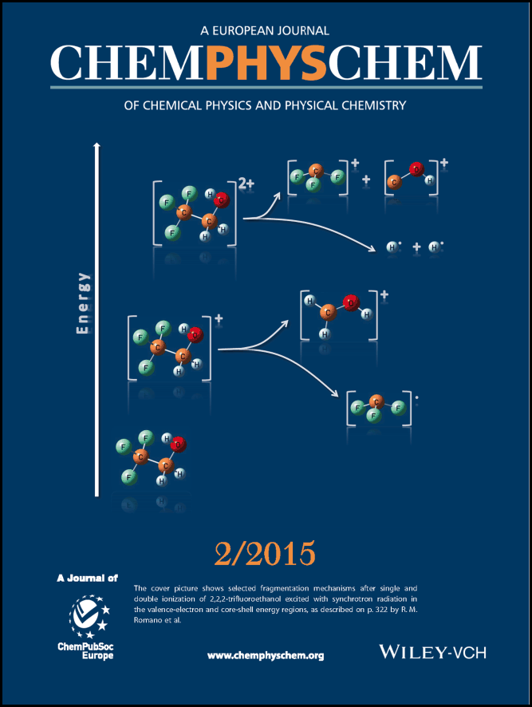

“Photoelectron Spectroscopy and Ionic Fragmentation of OSeCl₂ and its Analogue OSCl₂ under VUV Irradiation” M. Geronés, L. S. Rodríguez Pirani, M. F. Erben, R. M. Romano, R. L. Cavasso Filho, S. R. Tong, M. Ge, C. O. Della Védova. J. Phys. Chem. A, 2015, 119(29), 8000-8009. DOI: 10.1021/acs.jpca.5b02162

“Photofragmentation Mechanisms of Chlorosulfonyl Isocyanate, ClSO₂NCO, Excited with Synchrotron Radiation between 10 and 1000 eV” A. Moreno Betancourt, Y. B. Bava, Y. Berrueta Martínez, M. F. Erben, R. Cavasso-Filho, C. O. Della Védova, R. M. Romano. J. Phys. Chem. A, 2015, 119(29), 8021-8030. DOI: 10.1021/acs.jpca.5b02396

“Structure and Conformation of (CH₃)₃CSNO” A. Canneva, M. F. Erben, R. M. Romano, Y. V. Vishnevskiy, C. G. Reuter, N. W. Mitzel, C. O. Della Védova. Chemistry – A European Journal, 2015, 21(29),10436-10442. DOI: 10.1002/chem.201500811

“Structures of Trichloromethyl Thiocyanate, CCl₃SCN, in Gaseous and Crystalline State" Berrueta Martínez, Y.; Rodríguez Pirani, L.; Erben, M.; Boese, R.; Reuter, C.; Vishnevskiy, Y.; Mitzel, N.; Della Védova, C. O. ChemPhysChem, 2016, 17,1463-1467. DOI: 10.1039/C5CP01968K

“Intermolecular Interactions in Crystalline 1-(Adamantane-1-carbonyl)-3-subsituted Thioureas with Hirshfeld Surface Analysis” A. Saeed, M. Bolte, M. F. Erben,* H. Perez, CrystEngComm, 2015, 17, 7551-7563. DOI: 10.1002/cphc.201600063.

“Electronic properties and photofragmentation mechanisms of pyrosulfuryl chloride, ClSO₂OSO₂Cl” A. Moreno Betancourt, Y. B. Bava, M. F. Erben, R. Cavasso-Filho, S. R. Tong, M.F. Ge, C. O. Della Védova, R. M. Romano. Journal of Photochemistry and Photobiology A: Chemistry, 2016, 324, 184–191. http://dx.doi.org/10.1016/j.jphotochem.2016.03.019.

“Structures of Trichloromethyl Thiocyanate, CCl3SCN, in Gaseous and Crystalline State" Berrueta Martínez, Y.; Rodríguez Pirani, L.; Erben, M.; Boese, R.; Reuter, C.; Vishnevskiy, Y.; Mitzel, N.; Della Védova, C. O. ChemPhysChem, 2016, 17,1463-1467.

“Electronic Properties and Ionic Photodissociation of Thionitrite Compounds. Photoelectron Spectroscopy and Vacuum Ultraviolet Synchrotron Study on RSNO [R= (CH3)2CH– and (CH3)3C–]” A. Cánneva, R. L. Cavasso Filho, R. M. Romano, C. O. Della Védova, S. Tong, M. Ge, M. F. Erben*, ChemistrySelect, 2017, 2, 2021-2027.

“A close insight into electrostatic nature of weak intermolecular interactions in dihydropyrimidine-2(1H)- thione derivatives” A. Saeed, U. Flörke, A. Fantoni, A. Khurshid, H. Pérez, M. F. Erben*. CrystEngComm, 2017, 19, 1495-1508.

“The Effect of Chalcogen Substitution on the Structure and Spectroscopy of 4,7-Dimethyl-2H-chromen-2-one/thione Analogues” Z. Y. Delgado Espinosa, A. Saeed, G. A. Echeverría, O. E. Piro, M. F. Erben*. New Journal of Chemistry, 2017, 41, 5770-5783.

