Syed Muhammad Qaim
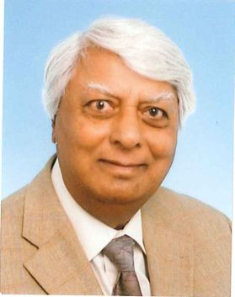
Syed Muhammad Qaim was educated up to M.Sc. at the Government College and Punjab University, Lahore, Pakistan. He did Ph.D. at Liverpool University, D.Sc. at Birmingham University, England, and Habilitation at Cologne University, Germany. In 1970 he joined the Institute of Nuclear Chemistry of the Research Centre Jülich and worked there in various capacities (Scientific Coworker, Group Leader, Division Leader, Acting Director, Vice Director) till his formal retirement in 2006. Since then he has been associated with his old institute in an advisory capacity. He also worked for about 18 years at Cologne University as Professor in Nuclear Chemistry. Since 2003 he holds a teaching assignment at the Jülich Campus of the Aachen University of Applied Sciences (FH), as well as an Honorary Professorship at his old Alma Mater (Government College University Lahore) in Pakistan.
Prof. Qaim has contributed to fundamental nuclear chemistry, nuclear data for energy- as well as non-energy related applications, and accelerator radionuclides for medical applications. He has published 415 research papers and edited 4 books. His most recent book on Medical Radionuclide Production was published in 2020 by Walter de Gruyter (Berlin/Boston). He has given special lecture courses at the universities in Assiut (Egypt), Debrecen (Hungary) and Rajshahi (Bangladesh), as well as at international schools of the IAEA. He was Co-Director of three courses at ICTP, Trieste. Presently he is a Tutor of an international course on Radioisotopes held every year in Seoul, Republic of Korea. He represented Germany in OECD-NEA (Paris) and IAEA (Vienna) for more than 20 years, with Chairmanship of the IAEA-Nuclear Data Committee for 6 years. Currently he is the Chairman of the Standing Committee on Education and Training of the World Council on Isotopes (WCI). He has been working as the Editor-in-Chief of the international journal Radiochimica Acta for the last 26 years.
Prof. Qaim has received a large number of honours and awards of various kinds in about 10 countries of the world, among them the JARI Medal of Pergamon Press, the International Hevesy Medal of Nuclear Chemistry, the Becquerel Medal of the Royal Society of Chemistry, two Honorary Doctorates, the civil award “Sitara-i-Imtiaz” by the President of Pakistan, and Fellowships of the Pakistan Academy of Sciences (PAS), Islamic World Academy of Sciences (IAS) and the Third World Academy of Sciences (TWAS).

